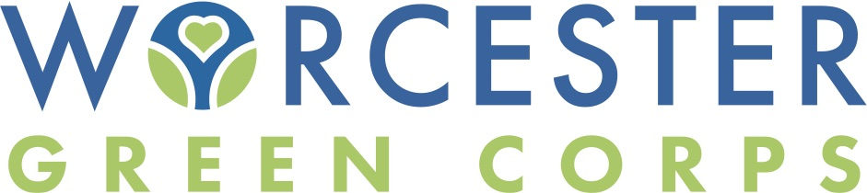

The Worcester Green Corps (WGC) is a public/private partnership between the Worcester Regional Chamber of Commerce, the City of Worcester, and the United Way of Central Massachusetts. As the city of Worcester experiences new levels of investment, it is in the community’s collective interest to make sure the commercial and residential streets and green spaces are clean and inviting on a year-round basis. The WGC supports efforts by city officials to address these issues by formally establishing a year-round program that leverages the involvement of the business and nonprofit communities to keep Worcester clean, green, and proactive in implementing beautification and environmental best practices throughout the city. In addition to the year-round cleanup and beautification efforts, the WGC has a career readiness program, which offers youth employment and exposure to a variety of career pathways and transferrable work skills. In order to continue this year-round program, we need your support. Thank you for your consideration.

For more information on sponsorship or opportunities for involvement, contact Miranda Hotham at mhotham@worcesterchamber.org or 508-753-2924 ext. 233

Worcester Green Corps Sponsorship Levels

Future Sponsor -- $15,000
- Showcased as “Future” sponsor on press release and any public notifications
- Opportunity to give collateral to WGC youth participants and other year-long volunteers
- Opportunity for company representative to speak at three career readiness sessions
- Opportunity for company representative to be interviewed on Tim Murray’s Chamber Exchange: the TV Show on Spectrum News1 about WGC
- Opportunity to have staff volunteer engagement
- Logo on the WGC landing page on the Chamber website
- Logo on 2 WGC features in the Chamber enews per year which is sent to over 10K business professionals in Central MA.
- Company mention and tag as sponsor on social media posts 10/year
- Company recognition and signage placement at 3 larger cleanups/year
- Company logo on 1-pager shared with businesses and residents in the area of cleanups about the program
- Company logo on apparel for our volunteers and youth workers (if committed by May 2022)
Supporting Sponsor -- $7,500
- Showcased as “Supporting” sponsor on press release and any public notifications
- Opportunity to give collateral to WGC youth participants and other year-long volunteers
- Opportunity for company representative to speak at one career readiness session
- Opportunity for company representative to be interviewed on Tim Murray’s Chamber Exchange: the TV Show on Spectrum News1 about WGC
- Opportunity to have staff volunteer engagement
- Company mention and tag on social media posts 5 times per year
District Sponsor -- $5,000
- Showcased as District X sponsor on all social posts in that district (opportunity to select district to support)
- Opportunity to request specific site for WGC team to attend to
- Opportunity for staff volunteer engagement
- Opportunity for company representative to speak at 1 career readiness session
- Company mention and tag as sponsor on social media posts 2 times per year
Apparel Sponsor -- $2,000
- Provides apparel for our volunteers and youth workers
- Opportunity to have staff volunteer engagement
- Showcased as apparel sponsor on press release and any public notifications
- Opportunity for company representative to speak at 1 career readiness session
Youth Sponsor -- $1,500
- Pays the salary of one youth worker for 12 weeks
- Opportunity to have staff volunteer engagement
- Opportunity for company representative to speak at 1 career readiness session
Supplies Sponsor -- $500
- Allows us to purchase materials throughout the year (garbo-grabbers, first aid kits, cleaning supplies, gloves, landscaping supplies)
- Opportunity to have staff volunteer engagement
- Company mention and tag on social media during first use of the supplies sponsored
Garden Sponsor -- $250
- Supports a greenery project
- Showcased as garden sponsor on social media posts about the site
- Plaque placed in garden bed showcasing support
Snack Sponsor -- $100
- Allows us to provide snacks and beverages to volunteers and youth workers
- Showcased as snack sponsor on social media posts about clean-up events

